Pfc LEO R . RUDY # 39388039
505 Th PIR compagnie b, 82 nd Airborne Division

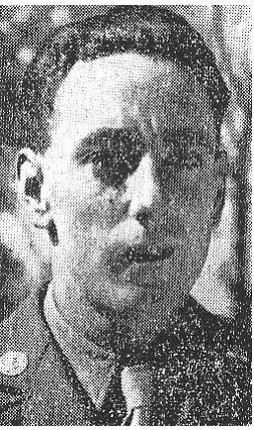

LEO R. RUDY wire of Mr. and Mrs. George Rudy de Bellingham (in the past Water-Clearly) state of Washington was born in 1920, it had a Wesley brother and a Edith sister
He attended the Water-Clearly Bellingham public schools and after 4 years of secondary studies was diploma in 1939 with old 19 years.
He then worked in the civil one with packing, labelling, marking, the setting out of bottle and various related professions.
He took on March 5, 1942 with LEWIS FT WASHINGTON in the regular army, for the duration of the war + 6 months, with the discretion of the president or other, in accordance with the law.
Private First Class LEO R. RUDY, is a veteran of 5 great battles, he arrived in May 1942 to Europe and fought in Sicily, Italy, Normandy, Holland, Belgium and in Germany.
It was killed on February 11, 1945 around the village of Schmidt (Germany).
It was to bury temporarily on February 13, 1945 in tomb # 30-5-97 with the provisional cemetery (1944-1949) of Henri - Vault, to date it rests now in the Plot tomb: D Line: 11 Fall 7 .
It was decorated with BRONZE STAR and PURPLE HEART WITH OAK LEAF CLUSTER.
He was not married and left in addition to his parents, a EDITH sister, his grandmother Ellen Rudy, his large father Jacob Rudy all domiciled road 4 Water-Clearly, an uncle Walter Rudy and a brother Wesley (bud) who was in the marine of the United States and stationed in Pearl Harbor

“It came with so many others, to trust to fight for our delivery, it fell for us, do not leave it in the indifference”
With its memory Timmermans Claude

